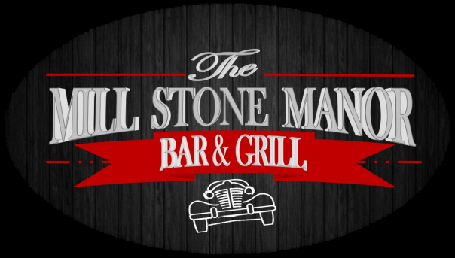

Dining Hours Bar
Sunday 10AM - 9PM 11AM–CLOSE
Monday 3PM - 9PM 3PM -CLOSE
Tuesday 3PM - 9PM 3PM -CLOSE
Wednesday 11AM - 9PM 11AM- CLOSE
Thursday 11AM - 9PM 11AM- CLOSE
Friday & Saturday
11AM - 10PM 11AM - CLOSE

Happy Hour Specials
Monday thru Friday 4pm to 6pm Sunday 10am to 2pm
Saturday 2pm to 5pm All you can eat Pancakes & Bacon
with fruit toppings $10.00
Drinks
Tucker $5.00 Monday Feature Night
Nessie Ray $5.00
Tuesday
Beer Wednesday Wing Night
20z Miller Light $3.00 Thursday
20z Blue Moon $5.00 Friday
Saturday
Wine
Rosatello (Sweet) $4.00
Black Box Cabernet (Dry) $4.00 ** Ask your server for our “ In House Specials”

Food
House-Made Breadsticks $4.00
Chips & Dip $4.00
Mozzarella Sticks (3) $4.00
½ Dozen Wings $4.00

June ** Monday Night Features
June 5 -
June 12
June 19
June 26

